|  |  |  |
| --- | --- | --- |
|  | **Rochester Institute of Technology**  **Golisano College of Computing and Information Sciences**  **School of Interactive Games and Media**  **2145 Golisano Hall – (585) 475-7680** |  |

**Data Structures & Algorithms for Games & Simulation II**

**IGME 309, 2016-17 Spring**

**E15: Bullet Configuration**

1. Use an existing solution or create one following previous ICEs, this example is best based on the Sandbox
2. Unzip the provided Bullet library and add it to the include folder of your project
3. In the project properties for all configurations add $(SolutionDir)include\Bullet\lib in the Library Directories. For both the Debug and the Release: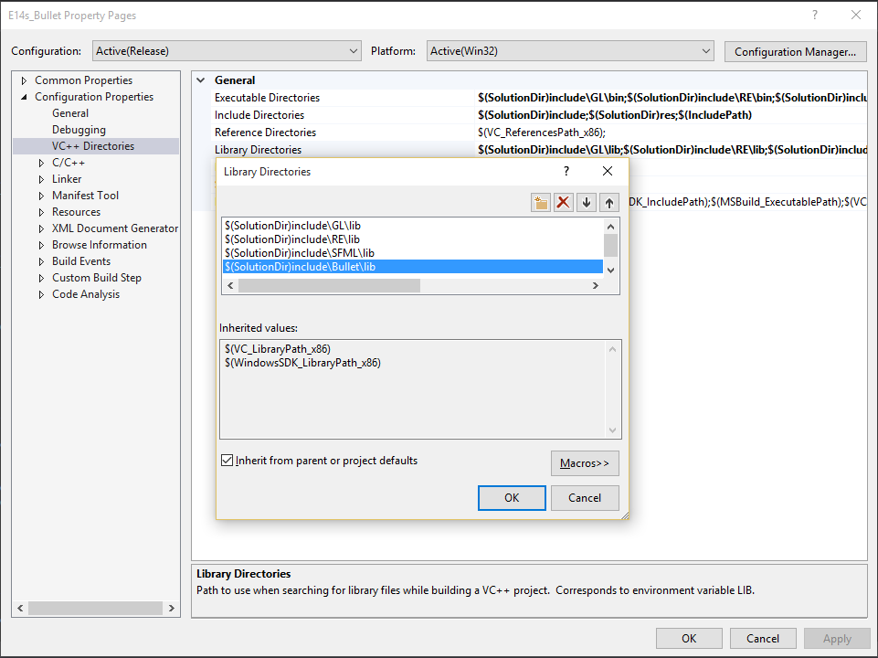
4. For Debug mode under C/C+/>Code Generation>security Check, set the runtime library to Multi-threaded Debug (/Mtd) and for release to Multi-threaded (/MT)

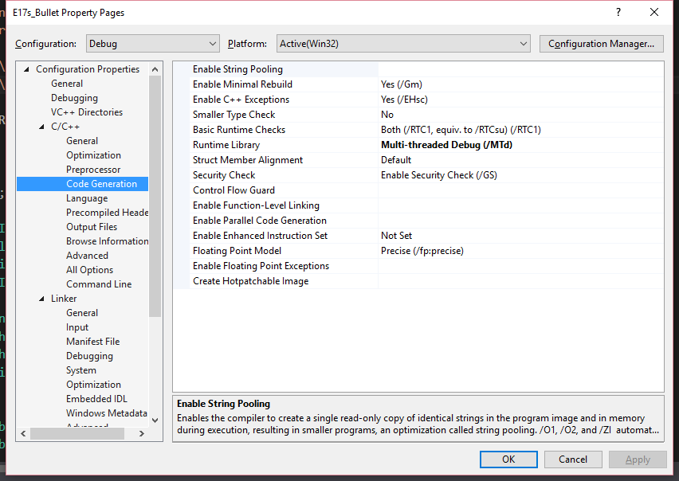

1. Under Linker>Input>Additional Dependencies add

For Debug:

BulletCollision_vs2010_Debug.lib

BulletDynamics_vs2010_Debug.lib

LinearMath_vs2010_Debug.lib

For Release:

BulletCollision_vs2010.lib

BulletDynamics_vs2010.lib

LinearMath_vs2010.lib

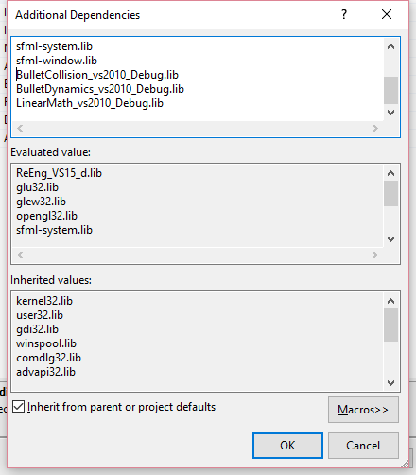

1. Copy/Ovewrite the AppClass.h and AppClas.cpp with the provided files and compile your code under Release mode (this should work under Debug mode as well but there is an unforeseen error with the library configuration so do not worry about it)
2. You should see a bunch of cubes falling from the sky.

Your in-class exercise consists in, making all the changes so your program compiles and runs, and then commenting the code you see.

Answer the following:

1. What is the real use of the black plane?
   1. To provide a clear sense of what the ground is in the project, as far as I can tell. It’s not connected to any variables.
2. What is a broadphase in Bullet?
   1. The collision manager – similar to the BOManager / Octree combination that we use in our projects. It handles two sets of objects for faster and more efficient collision resolution.
3. What is the btBoxShape used for in Bullet?
   1. To describe the shape of the rigid bodies of the cubes – so that physics and collision can be simulated appropriately.

Submit individually to the dropbox (this is not a group ICE)